West Virginia Board of Examiners for Speech-Language Pathology and Audiology

January 15, 2026
Time: 5:30 PM Board Meeting
Location: Video Conference Meeting Board Office
99 Edmiston Way – Suite 214
Buckhannon, WV 26201

Present: Board President, Vickie Pullins
Board Secretary, Amber Settles
Board Member, Dr. Michael Zagarella
Board Member, Heather Waselchalk
Board Member, Amanda Bonner
Board Member, Ruth Rowan
Board Attorney, Joanne Vella

Executive Director, Pamela Coughlin

The January 15. 2026 meeting of the West Virginia Board of Speech-Language Pathology and Audiology was called to order at the Board office at 99 Edmiston Way, Buckhannon, West Virginia, via Zoom at 5:30 PM by Board President Vickie Pullins. Agenda and Zoom invitation were put on the Boards website for the public to attend via telephone.

Ruth Rowan made a motion to approve board meeting minutes for November 4, 2025 and December 5, 2025. Amber Settles seconded the motion. Motion carried.

Amber Settles made a motion to approve Pcard for October 2025 and November 2025. Heather Waselchalk seconded the motion. Motion carried.

Pam Coughlin informed the Board that the Audiologist received his refund on January 7, 2025.

Vickie Pullins expressed to the Board it had been her honor to work with wonderful group of colleagues and professionals that represent both the Audiology, Speech Pathology and Hearing Aid Dispensers.
Ms. Pullins stated her time now is focused on the Interstate Compact due to many states who passed the Legislation, there has been no movement. She also mentioned the Compact lost their Executive Director.
Ms. Pullins stated she wants to devote her time to the Interstate Compact.

Ms. Pullins asked the Board members if they would like to entertain any nominations for President and Secretary of the Board. Dr. Michael Zagarella made a motion to nominate Amber Settles for President and Heather Waselchalk for Secretary. Ms. Pullins asked Amber Settles and Heather Waselchalk if they are willing the serve the Board, both a said yes. Amanda Bonner seconded the motion. Motion carried.

Pam Coughlin asked the Board if they would like to sponsor WV Speech-Language-Hearing Association Conference on April 28, 2026 and April 29, 2026. Ms. Coughlin informed the Board that in 2025 the Board approved to sponsor WVSHA in the amount of $100. Ms. Pullins recommended we should do more than $100 because it is a continuing education event. It was also mentioned that the Board should sponsor the American Academy of Audiology (AAA) convention and WV Hearing Society . Dr. Zagarella stated Danny Mason would be the contact for AAA Conference. Pam Coughlin will reach out to him to get more information on sponsoring their conference. Amanda Bonner will reach to WV Hearing Society and see about sponsoring their conference.

Dr. Michael Zagarella made a motion to sponsor WVSHA gold package for $300 and one snack break for $250. Amanda Bonner seconded the motion. Motion carried.

Pam Coughlin informed the Board that we are set up for the E-Travel in WVOASIS. This new travel system will automatically upload all PCard transactions for lodging, registration fee and airfare.

Pam Coughlin informed the Board that the Purchasing Division audited the Boards PCard transactions on
January 7, 2026. The auditor stated the Board needed to use Stationers, Inc for office supplies because they hold the statewide contract. If the company does not have what we need, we need to get a waiver from the Purchasing Division to order from Office Depot or Amazon. Amber Settles stated everything looked good on the Purchasing Audit review.

Heather Waselchalk stated Marshall University discontinued the Speech-Language Pathology Assistant certification program due to low interest and limited job prospects. Ms. Pullins stated until Medicare and Medicaid decide to allow Speech-Language Pathology Assistants to bill for services and the Department of Education decides that someone with a 2 year degree can be a SLPA, there is really no job market for them.

Amber Settles mentioned to the Board that National Council of State Boards of Examiners (NCSB) will be having a Board meeting March 6th and 7th of 2026 in Denver, Colorado and asked the Board to approve their travel. Amanda Bonner made a motion to approve travel for Vickie Pullins and Amber Settles. Ruth Rowan seconded the motion. Motion carried.

Vickie Pullins made a motion to go into Executive Session. Dr. Zagarella seconded the motion. Motion carried.

Dr. Michael Squires made motion to come out of Executive Session. Vickie Pullins seconded the motion. Motion carried.

Amber Settles stated Pam Coughlin reviewed the Hearing Aid Dealer complaint #6 with Board in Executive Session. Ms. Coughlin will follow up on Hearing Aid Dealer complaint to make sure the consumer received their full refund for their hearing aids. Ms. Coughlin will update the Board at the next meeting and see if there are any further needs for this complaint.

Amanda Bonner made motion to adjourn. Ruth Rowan seconded motion. Motion carried.

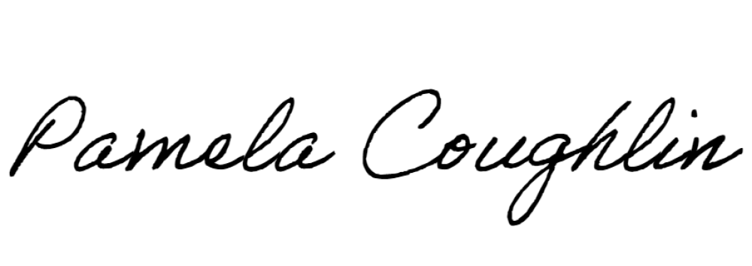
Respectfully submitted,

Pamela Coughlin, Executive Director
for
Amber Settles, Board Secretary

